ANTI-BULLYING & ANTI-HARASSMENT POLICY
Morley Town Council
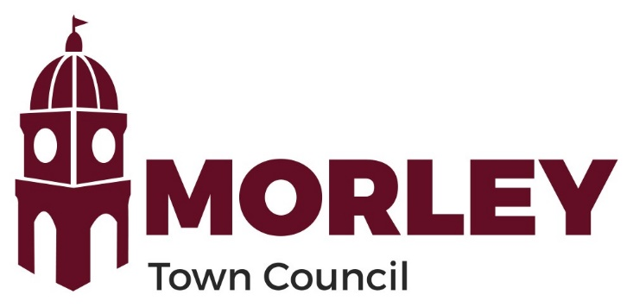

Contents

Contents 2
Introduction 3
Definition 3
Informal Stage 4
Formal Stage 5
Our Commitments Under this POlicy 5
General 6
Version Control 6

Introduction

The Council is committed to providing an environment free of bullying and harassment.
The Council will treat all complaints of harassment seriously and will investigate them promptly, efficiently and in confidence.
The main aim of this policy is to provide a framework for resolving complaints of harassment or bullying and for stopping any behaviour that is causing offence or distress.
Employees have an absolute right to complain if they are treated in a manner that they believe constitutes harassment or bullying. This will include behaviour that has caused offence, humiliation, embarrassment or distress.
Employees who raise a genuine complaint under this policy will under no circumstances be subjected to any unfavourable treatment or victimisation as a result of making a complaint.
Bullying and harassment is a disciplinary offence: incidents will be dealt with under the Council’s disciplinary process and could result in dismissal.

Definition

Bullying and harassment is:
- unwanted conduct, verbal or otherwise, which refers to a protected characteristic and which affects the dignity of men or women at work; or
- offensive, intimidating, malicious or insulting behaviour, an abuse or misuse of power through means intended to undermine, humiliate, denigrate or injure the recipient. ‘Power’ doesn’t always refer to a position of authority, but a use of personal strength and/or the power to coerce through fear or intimidation.
Bullying and/or harassment may be one person against another or it may involve groups of people. It may be obvious or underhand. It may take place in private or in public. It may be face-to-face or in written or spoken communications e.g. email or phone call.
Whatever form it takes it is unwarranted and unwelcome to the individual.
A single incident can amount to harassment.
Legitimate, constructive and fair criticism of your performance or behaviour at work is not bullying.
Examples of bullying and harassment can include:
- banter or jokes based on protected characteristics
- unwanted physical conduct or "horseplay", including touching, pinching, pushing, and grabbing
- the display of material with sexual, racial or offensive overtones (even if not directed at the complainant)
- sarcastic personal remarks about colleagues, especially those reporting to you
- racist, sexist, homophobic or ageist jokes, or derogatory or stereotypical remarks about a particular ethnic or religious group or gender.
- over-demanding or unnecessary requirements.
Harassment is not always intended. A light-hearted joke or ‘banter’ can be taken as offensive by some employees. It is important, therefore, to be sensitive to the feelings of others when thinking about your behaviour in the workplace.
If you feel you are being bullied or harassed by any third party or another employee, tell your Line Manager/Liaison Councillor or any other Councillor who you feel comfortable talking to immediately.
Bullying and harassment situations will be dealt with under the Resolution process.
Please note that bullying and harassment at work-related events outside of your normal workplace e.g. at Christmas parties or training courses, will not be tolerated and will also be subject to this policy.

Informal Stage

If you feel you have been subjected to unwanted conduct amounting to bullying and harassment, you should firstly try to resolve the problem informally by talking to the individual concerned, explaining that the behaviour is not acceptable and that it offends you, or makes you uncomfortable.
If you find this difficult, you should seek assistance from your Liaison Councillor or another Councillor that you feel comfortable approaching.
An informal approach will be confidential and will not result in a report to anyone in the Council without your knowledge. The person you asked for assistance will, at your request, either coordinate in an informal meeting between you and the individual concerned; will approach the individual concerned on your behalf or escalate the matter to someone who is able to approach the individual concerned. This decision will be made with you.
The informal stage will not result in any formal internal investigation or disciplinary action but is intended to enable you to resolve the matter yourself without it going any further in the Council.
If you consider that you may have been subjected to conduct amounting to a criminal offence (such as a sexual assault), the person you approached for assistance will support you to make a formal complaint to a police officer or to provide you with any other assistance you may require, including signposting to external support. The assisting member of staff will also inform your Liaison Councillor of the situation or support you in informing them if you haven’t done so.

Formal Stage

Where informal resolution is not appropriate, is not requested or where the outcome of the informal process has been unsatisfactory, you may make a formal complaint to your Line Manager/Liaison Councillor a councillor, or the Monitoring Officer.
Any such complaint will be dealt with under the Council’s Resolution process. Where possible, consideration will be given to ensuring that you and the alleged harasser are not required to work together whilst the complaint is under investigation.
Where a complaint has been upheld, consideration will be given, where possible, to permitting you to choose whether you wish to remain in your current post or to work elsewhere, eg another department, from home etc.
The Council will ensure that you are not penalised for making a complaint and will monitor the situation to ensure that the harassment has stopped.
Where a complaint is not upheld, the Council will consider making arrangements which will try to prevent the 2 parties working together.
If it is established that you have made a deliberately false or malicious complaint accusing another person of harassment or bullying, disciplinary action will be taken against you. Harassment and bullying is taken very seriously and if you are found to be bullying or harassing other employees you will be subject to the Council’s disciplinary process.
Counselling or mediation may be considered, particularly where investigation shows no course for disciplinary action, or where it may be useful to help resolve the issue or help support the person accused as well as the complainant.

Our Commitments Under this POlicy

The Council undertakes to provide the following measures and ways of working to support colleagues and to minimise bullying and harassment at work:
- Working with employees to create a culture where bullying, harassment and discrimination is not accepted.
- Providing training for all employees to raise awareness of everyday behaviours that create a negative environment.
- Ensuring that managers are aware of their obligations to promote a positive working environment for their staff and colleagues as defined within this policy.
- Ensure staff are aware they are able to, and feel comfortable about, disclosing issues without fear of discrimination or reprisal.
- Providing appropriate support for individual staff who are experiencing bullying and harassment internally and externally. Externally by proactively making employees aware of external companies that might be able to provide information, advice and support in these situations.
- Ensuring that our working practices promote practices that guarantee employees are treated fairly and without discrimination
- Being mindful of the Council’s responsibilities under The Equality Act 2010.
- By encouraging staff to raise any concerns at the earliest opportunity, or in the least, during 121 meetings with their Line Manager/Liaison Councillor
- When matters are raised under this policy, prioritising the issue and taking prompt action.

General

The Council aims to keep policies up to date and right for everyone. Therefore, this policy may be amended from time-to-time, and it does not form part of your contract of employment.

Version Control

Date | Amendment | Approved by | Version No.
05/02/2020 | Created | Karen Oakley | v1
01/05/24 | Full review and update |  | v2
20 May 2026 Reviewed and adopted by Full Council

