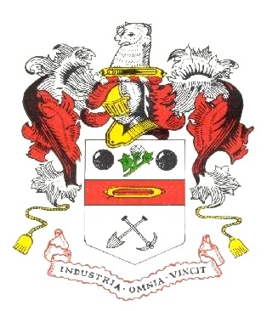

YOU ARE SUMMONED TO A MEETING

OF MORLEY TOWN COUNCIL
TO BE HELD ON WEDNESDAY, 24th JUNE 2026 AT 7.00 PM

MORLEY COMMUNITY CHURCH, ZION CHAPEL, MERLYN REES AVENUE, MORLEY LS27 9SL

Please note - people attending must not park in the adjoining car park of Haydn Court - this is a private car park for residents only. There is adequate parking in Morrisons Car Park or in the parking bays outside Morley Elderly Action in Wesley Street. Haydn Court car park should also not be used for drivers dropping off passengers using the side entrance path - they should walk the few yards from Wesley Street.

A G E N D A

1. To record attendance

2. To receive apologies for absence given in advance of the meeting

3. To consider the approval of reasons given for absence

4. Declarations of Disclosable Pecuniary and Other Interests
To disclose or draw attention to any disclosable pecuniary interests for the purposes of Section 31 of the Localism Act 2011 and paragraphs 13-18 of the Members’ Code of Conduct. Also to declare any other significant interests which the member wishes to declare in the public interest, in accordance with paragraphs 19 to 20 of the Members’ Code of Conduct

5. Presentation of the Past Mayor's Jewel to Cllr S Brown

6. To consider and approve the Annual Internal Control Review for 2025/26 to be conducted by a Member of the Audit Committee and the Town Clerk on 23rd June 2026 (copies to follow), as follows:-
(i) Internal Control checklist
(ii) Review of Effectiveness of Internal Audit checklist
(iii) Annual Internal Control Review 2025/26

7. To receive, consider & approve any actions recommended relating to the Internal Audit Report prepared by Heelis & Lodge. The internal audit was scheduled to be conducted remotely on Saturday 23rd May 2026. As of Thursday 11th June 2026, this has not been received, despite sending emails to expedite this; therefore, information relating to this will be forwarded to members when it arrives. (copy to follow)

8. To approve the Annual Governance Statement 2025/26 – Section 1 (p.4) of the Annual Governance & Accountability Return for the year ended 31st March 2026 (copy attached)

9. To approve the Accounting Statements for 2025/26
– Section 2 (p.5) of the Annual Governance & Accountability Return for the year ended 31st March 2026 (copy attached), as follows: -
(i) Consider the Accounting Statements by the members meeting as a whole;
and
(ii) Approve the Accounting Statements by resolution;
and
(iii) Ensure the Accounting Statements are signed and dated by the Chairman of this meeting

10. To agree the period for the Exercise of Public Rights and the publication of the unaudited Annual Governance and Accountability Return will commence on Friday, 26th June 2026, and end on Thursday, 6th August 2026

11. To consider recommendations from F & GP meeting of 16th June 2026 with regards to Grants to
(i) Morley in Bloom £23,147.00
(ii) Churwell Environmental Group £10,030.00 +vat

12. To receive item(s) of correspondence (for information)

13. The date and time of the next scheduled meeting is Wednesday, 15th July 2026, at 7.00pm

Martyn Bolt
Deputy Town Clerk
18/6/26

